Project Design Phase-II Technology Stack (Architecture & Stack)

|  |  |
| --- | --- |
| Date | 03 11 2022 |
| Team ID | PNT2022TMID37921 |
| Project Name | Project – Global sales data analytics |
| Maximum Marks | 4 Marks |

# Technical Architecture:

The Deliverable shall include the architectural diagram as below and the information as per the table1 & table2

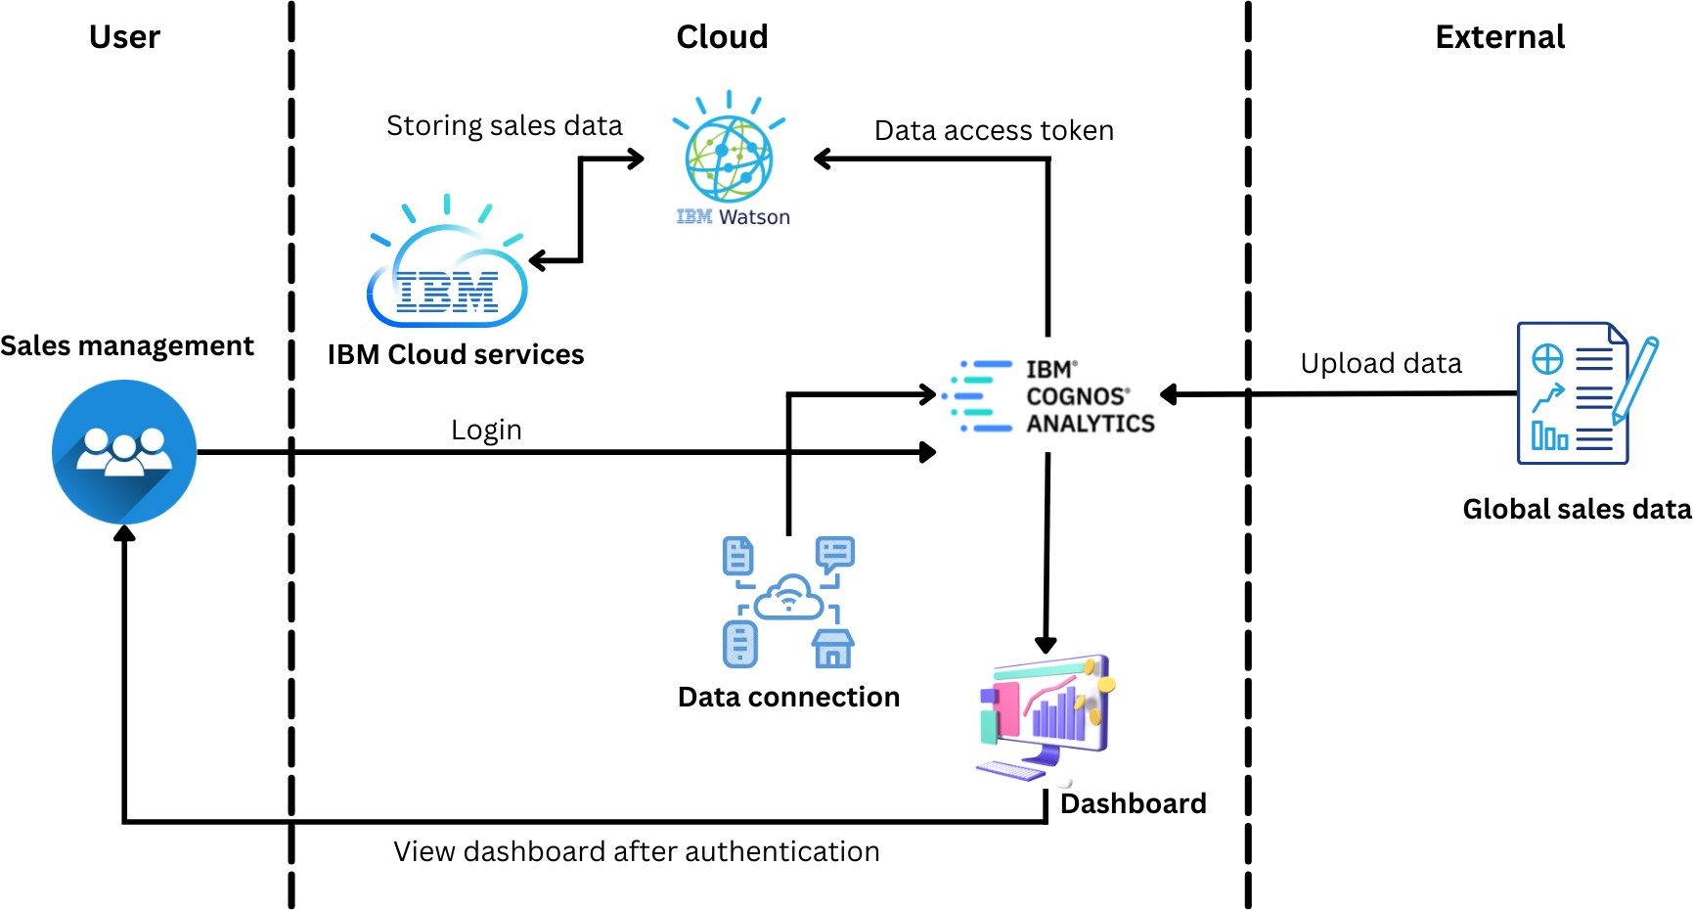

# Table-1 : Components & Technologies:

|  |  |  |  |
| --- | --- | --- | --- |
| **S.No** | **Component** | **Description** | **Technology** |
| 1. | User Interface | user interacts with application or web | IBM Cognos analytics |
| 2. | Dataset | Global sales dataset is uploaded |
| 3. | Working with the dataset | Cleaning, extracting process is done with the dataset. | IBM Cognos analytics with Watson |
| 4. | Data exploration | Information in the data is identified according to the requirements | IBM Cognos analytics |
| 5. | Data visualization | Various data are represented in charts, graphs according to need of the customers. |
| 6. | Data demonstration (results) | The charts, graphs are represented to customers through dashboards, story, and report. | IBM Cognos analytics with Watson |
| 7. | Cloud Database | Database Service on Cloud | IBM DB2, IBM Cloudant |
| 8. | File Storage | File storage requirements | IBM Block Storage or Other Storage Service or Local Filesystem |

**Table-2: Application Characteristics:**

|  |  |  |  |
| --- | --- | --- | --- |
| **S.No** | **Characteristics** | **Description** | **Technology** |
| 1. | Open-Source Frameworks | List the open-source frameworks used | IBM Cognos |
| 2. | Security Implementations | Secure storage and access of information | Active directory |
| 3. | Scalable Architecture | Support different in data size | IBM cloud |
| 4. | Availability | Multiple reports are viewed ignoring the platform and specifications | IBM cloud |
| 5. | Performance | Large amount of information can be processed | IBM Cognos analytics with Watson |